ECA5604-5G/6G COMMUNICATION SYSTEMS
NAME: V Sadhana
REG NO: 192412242
Exp 8: Steering Angle Variation in MIMO Beamforming Using MATLAB
Objective-1
Analyze different steering angles of a MIMO beamforming system using MATLAB. Observe how the beam can be directed toward various target directions by varying the steering angle.
Code:
clc;
clear;
close all;
angle = [-60 -30 0 30 60]; % Steering Angles (degrees)
gain = ones(size(angle)); % Normalized Gain
figure
polarplot(deg2rad(angle), gain,'o-','LineWidth',2)
title('Steering Angle Variation in MIMO Beamforming')
Output:
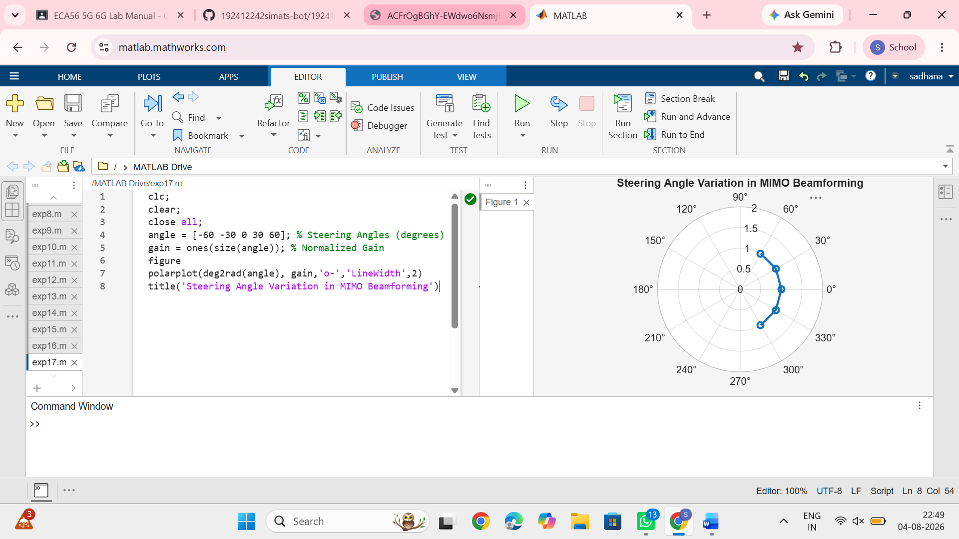
Objective-2
Compare the array gain obtained at different steering angles using MATLAB. Observe the improvement in signal strength achieved through beamforming.
Code:
clc;
clear;
close all;
angle = [-60 -30 0 30 60]; % Steering Angles (degrees)
gain = [9 12 15 12 9]; % Array Gain (dB)
figure
bar(angle, gain)
grid on
xlabel('Steering Angle (Degrees)')
ylabel('Array Gain (dB)')
title('Array Gain for Different Steering Angles')
Output:
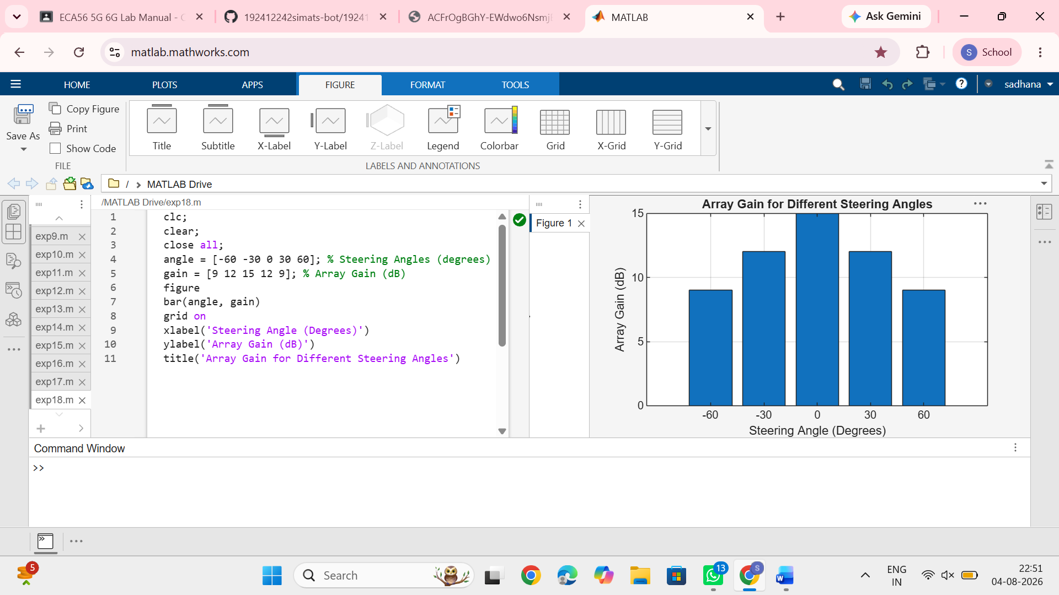
Objective-3
Analyze the difference between the desired steering angle and the measured beam direction using MATLAB. Compare the beam direction error for various steering angles and evaluate the beam steering accuracy.
Code:
clc;
clear;
close all;
desired = [-60 -30 0 30 60]; % Desired Steering Angle (degrees)
actual = [-58 -32 1 29 62]; % Actual Beam Direction (degrees)
error = abs(desired - actual); % Beam Direction Error
figure
plot(desired, error, 'o-', 'LineWidth', 2)
grid on
xlabel('Desired Steering Angle (Degrees)')
ylabel('Beam Direction Error (Degrees)')
title('Beam Direction Error for Different Steering Angles')
Output:
